**Centralized and Integrated Doctor Appointment Booking Platform - CIDABP**

1Ms M Bhuvana,2Vijay A, 3Surya D, 4Vasanth N,5Manimurugan S

Assistant Professor Dept. of Information Technology

Student, Sri Shakthi Institute of Engineering and Technology

Student, Sri Shakthi Institute of Engineering and Technology

Student, Sri Shakthi Institute of Engineering and Technology

Student, Sri Shakthi Institute of Engineering and Technology

________________________________________________________________________________________________________

***Abstract :***

The comprehensive system known as the Centralized and Integrated Doctor Appointment Booking Platform (CIDABP) was created to expedite the procedure of scheduling patient appointments at various institutions. By enabling patients to schedule appointments not just within a single hospital but also across many hospitals that are incorporated into the system, this platform streamlines the scheduling process. The four main user roles that CIDABP serves are Admin, Hospital Administrator, Doctor, and Patient.

In addition to managing hospitals and patients registered on the platform, the Admin function is in charge of overseeing the entire system. Hospital administrators oversee the scheduling of physicians and make sure that appointments are arranged smoothly within their particular healthcare facilities. Convenience of using a single platform to schedule appointments with preferred physicians and hospitals is advantageous to patients.

# ***Index Terms – Healthcare management, appointment scheduling, hospital administration, patient management, centralized platform, integrated system, user roles, administrative interface, doctor scheduling, patient booking, efficient coordination, streamlined healthcare services.***

# **Introduction**

The Centralized and Integrated Doctor Appointment Booking Platform (CIDABP), which provides a comprehensive solution for effective appointment scheduling across various hospitals, is revolutionizing the healthcare industry. Without the need for separate booking systems, CIDABP acts as a centralized hub where patients can easily schedule appointments with physicians from different hospitals. CIDABP optimizes resource use and streamlines the entire process by providing distinct user roles such as Admin, Hospital Administrator, Doctor, and Patient. This allows for better collaboration between healthcare providers and patients. In the end, this web-based tool promotes a more effective and integrated healthcare ecosystem by streamlining appointment scheduling and enhancing accessibility and convenience for patients and healthcare providers alike.

# **Problem Statement**

1. **Difficulties in Making Appointments:** Extended waiting periods for individuals to schedule appointments present a noteworthy obstacle in the healthcare system, perhaps exacerbating pre-existing medical issues. Patients find it difficult to obtain appropriate appointment times when scheduling conflicts arise across numerous hospitals. These problems are exacerbated by ineffective communication channels, which result in miscommunication and missed appointments.
2. **Burdens of Administration:** Healthcare facilities' administrative resources are heavily burdened by manual appointment management procedures, which takes important staff members away from vital duties. In hectic healthcare environments, monitoring patient records and scheduling becomes more and more difficult. Appointment scheduling is complicated by a lack of centralized control and oversight, which reduces overall efficiency.
3. **Effect on the Experience of the Patient:** Problems with appointment scheduling have a negative effect on the patient experience and cause annoyance and discontent. Prolonged wait times and scheduling challenges reduce patient participation and diminish confidence in the healthcare system. Reduced attendance at doctor's appointments aggravates these problems even more and may have a negative impact on one's health.
4. **Difficulties in Utilizing Resources:** Ineffective appointment scheduling procedures put stress on staff and facilities and result in an underutilization of healthcare resources. For healthcare providers, this misallocation has serious financial ramifications. In order to guarantee effective healthcare service delivery and the long-term viability of healthcare institutions, it is imperative to tackle resource usage concerns.
5. **Requirement for a Whole Solution:** A thorough approach is obviously required to solve the problems with appointment scheduling in the healthcare industry. In order to guarantee smooth appointment scheduling for patients and providers alike, such a system must place a high priority on accessibility and user-friendliness. Simplified channels of communication between patients and providers are necessary to enable effective scheduling. Improving the entire delivery of healthcare services can be achieved through optimizing the allocation and usage of resources.
6. **Objectives of the Solution:** The main objectives of the solution are to decrease wait times and scheduling conflicts while also improving patient satisfaction and experience. In order to do this, healthcare providers' productivity and efficiency must be increased through improved appointment scheduling procedures. Allocating resources as efficiently as possible would also guarantee prompt access to services and increase the effectiveness of healthcare institutions.

The creation of an all-inclusive appointment management solution seeks to improve the healthcare scheduling process for the benefit of patients and healthcare professionals by tackling these issues and supporting the previously mentioned objectives.

# **Existing Solution**

By combining technology and administrative efficiency, a number of current solutions in the field of healthcare administration and appointment scheduling give patients and healthcare professionals with improved experiences and streamlined operations. Here are a few instances:

1. **Software for scheduling and managing appointments:** Patients can schedule appointments with healthcare professionals from a variety of specializations and locations using centralized platforms like Doctolib, Practo, and Zocdoc. These solutions streamline the scheduling process and cut down on patient wait times by providing user-friendly interfaces, real-time availability updates, and appointment reminders.
2. **Electronic Health Record (EHR) Systems:** These systems, which include Allscripts, Epic, and Cerner, allow medical professionals to handle clinical processes, patient appointments, and medical information in a consolidated digital environment. By providing functions including patient registration, appointment scheduling, medical billing, and interface with other healthcare systems, these systems enhance the accuracy and efficiency of healthcare administration.
3. **Telemedicine Platforms:** Virtual appointments and remote consultations between patients and healthcare providers are made possible by telemedicine platforms such as Teladoc, Amwell, and Doctor on Demand. With the use of these platforms, patients may receive medical care from the comfort of their homes and avoid making in-person appointments. They also provide secure video conferencing, chat messaging, and file sharing features.
4. **Patient Engagement and Communication Tools:** Secure messaging, appointment reminders, and instructional materials are just a few of the ways that healthcare providers can interact with patients with tools like Updox, Solutionreach, and Klara. These tools promote appointment adherence, foster better patient-provider contact, and give patients more control over their healthcare.
5. **Platforms for Healthcare Analytics and Reporting:** Healthcare companies can examine appointment data, patient demographics, and operational indicators with analytics systems like Tableau, Qlik, and Power BI to enhance scheduling procedures and resource allocation. These platforms enable healthcare administrators to make data-driven decisions and increase overall efficiency in appointment scheduling and management. They do this by providing customisable dashboards, data visualization tools, and predictive analytics capabilities.

Healthcare firms may maximize resource use in appointment scheduling and healthcare management, improve operational efficiency, and improve patient experience by utilizing these cutting-edge technologies.

# **Literature Survey**

A review of the literature on the Centralized and Integrated Doctor Appointment Booking Platform (CIDABP) would include a range of topics including technological integration, appointment scheduling, and healthcare administration. Important topics to research are as follows:

1. **Technology Integration:** Look at using digital tools like CIDABP to expedite the appointment-scheduling process and enhance patient-provider communication.
2. **Patient-Centric Approach:** Look at how CIDABP puts accessibility, convenience, and patient preferences first, which boosts engagement and satisfaction.
3. **Resource Utilization:** Examine how CIDABP helps healthcare facilities allocate resources most effectively, which boosts productivity and lessens administrative workloads.
4. **User Experience:** With an emphasis on usability and accessibility, assess the CIDABP interface considerations and user experience design concepts.
5. **Healthcare Efficiency:** Using key performance metrics like appointment wait times and scheduling accuracy, examine how the CIDABP affects healthcare productivity, efficiency, and operational performance.

Stakeholders can inform the development and implementation of centralized appointment booking platforms such as CIDABP in healthcare settings by researching relevant literature to obtain insights into the effectiveness and problems of these systems.

# **Proposed Solution**

In order to solve the intricacies involved in traditional healthcare appointment scheduling, the Centralized and Integrated Doctor Appointment Booking Platform (CIDABP), a sophisticated system, is being developed and put into use as part of the suggested solution. Advanced scheduling algorithms, real-time communication tools, and user-friendly interfaces will all be included in CIDABP, a comprehensive platform that will make bookings easier for both patients and healthcare professionals. Utilizing state-of-the-art technology, CIDABP will minimize wait times and scheduling conflicts by providing individualized appointment scheduling experiences based on each patient's preferences, medical needs, and availability. The platform will ensure effective personnel, equipment, and facility use by optimizing resource allocation amongst participating healthcare facilities through centralized control and oversight.

In addition, CIDABP will place a high priority on patient empowerment and involvement by providing interactive tools including virtual consultations, appointment reminders, and feedback systems, which will promote a team-based and patient-centered approach to healthcare administration. CIDABP prioritizes inclusivity and accessibility, offering offline access choices, smartphone compatibility, and multilingual support to meet the needs of a wide range of users. To ensure the platform is adopted and used seamlessly, hospital administrators and personnel will receive comprehensive training and support services. CIDABP promises to transform healthcare appointment scheduling by incorporating these cutting-edge features, enhancing effectiveness, accessibility, and patient pleasure in the process.

# **Executive Summary**

A ground-breaking system called the Centralized and Integrated Doctor Appointment Booking Platform (CIDABP) was created to improve and expedite the process of making doctor appointments at various healthcare facilities. By offering an integrated platform that puts efficiency, accessibility, and patient pleasure first, this all-inclusive platform tackles the issues that traditional appointment booking systems confront.

There are two primary modules in CIDABP: one for patients and one for healthcare practitioners. Patients may simply search for healthcare providers, browse available appointment slots, and book appointments based on their schedules and preferences thanks to the patient module's user-friendly interface. In order to increase convenience and participation, patients can also access virtual consultations and receive appointment reminders.

The platform provides solutions for effective resource allocation and appointment management for healthcare providers. To reduce wait times and scheduling conflicts, healthcare administrators can maximize resource use, manage hospital schedules, and coordinate doctor availability. Features for real-time communication make it easier for patients and healthcare professionals to communicate smoothly, improving teamwork and patient care. Interactive appointment scheduling, customized patient experiences, role-based access control, and browser and device compatibility are some of CIDABP's salient features. CIDABP seeks to transform the healthcare appointment booking process by utilizing cutting-edge technology and user-friendly design, enhancing effectiveness, accessibility, and general patient pleasure.

# **Business Viability**

Because CIDABP can address the increasing demand for effective and user-friendly healthcare appointment booking systems, it has great economic viability. By offering a complete and cutting-edge solution that makes scheduling appointments easier for patients and healthcare professionals, the platform responds to market demands.

CIDABP's tailored approach to appointment scheduling, which takes into account each patient's preferences and medical needs, is one of its distinctive selling advantages. Because of its unique value offer, CIDABP stands out from other booking solutions and is a desirable choice for medical facilities looking to increase patient retention and satisfaction.

Moreover, CIDABP provides additional revenue streams via partnerships with content providers, premium features, customization choices, and subscription licenses for healthcare facilities. The platform's economic feasibility and prospects for expansion in the healthcare technology market are attributed to its scalability, accessibility, and long-term sustainability.

# **Advantages**

CIDABP has many benefits that improve the way that patients and healthcare providers schedule appointments for medical care. Among these benefits are:

1. Personalized experiences and interactive scheduling elements improve patient happiness and engagement.
2. Reduced wait times and schedule conflicts as a result of increased healthcare facilities' efficiency and resource usage.
3. Patient flexibility and accessibility in scheduling appointments from any device or place, enhancing access to medical services.
4. Scalability and financial savings for healthcare organizations by eliminating administrative costs and centralizing appointment scheduling.
5. Improved patient-provider communication and safety protocols, guaranteeing a safe and effective appointment scheduling procedure.

All things considered, CIDABP offers a complete and practical solution for centralized and integrated scheduling of medical appointments. Its advantages include enhanced patient experiences, streamlined business processes, and financial sustainability for healthcare institutions.

# **Modules**

A number of modules make up the Centralized and Integrated Doctor Appointment Booking Platform (CIDABP), which unifies healthcare professionals and patients into a comprehensive and effective system. Securing access is ensured by the user authentication and role management module, which permits administrators, hospitals, and patients to log in with the right authorization. Patients can easily manage their healthcare appointments with the use of the patient module's capabilities, which include appointment scheduling, reminders, and virtual consultations. The platform has modules for doctors and hospital administrators on the side of the healthcare providers. Administrators can control hospital scheduling, physician availability, and appointment times with the help of the hospital administrator module. The doctor module gives medical professionals the ability to communicate with patients, manage patient appointments, and monitor their own schedules.

CIDABP uses a powerful database system, such MySQL, for efficient data management in order to store and arrange administrative data, patient data, and appointment details. Administrators can learn more about patient involvement, resource usage, and appointment trends by integrating with analytics tools.System administrators can also handle user accounts, settings, backups, and other administrative chores by using the system administration functions. Together, these modules provide effective appointment scheduling, safe access, data administration, and system upkeep. They also serve as the foundation of CIDABP.

# **Output**

**Admin Module:**

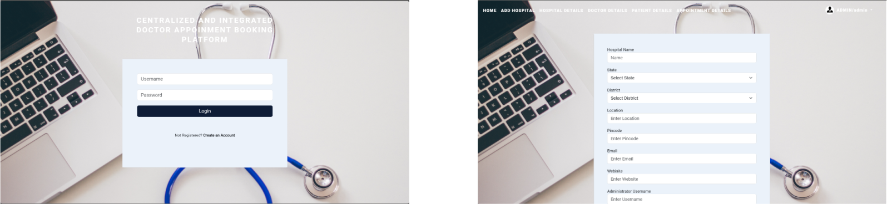

**Hospital Administrator Module:**

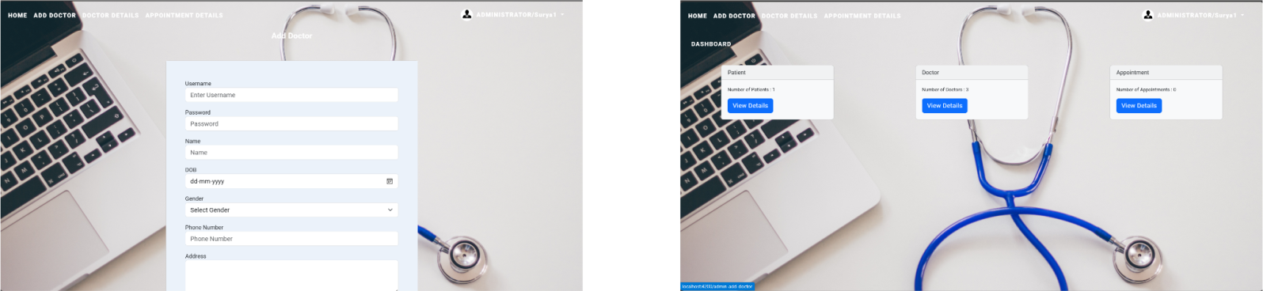

**Doctor Module:**

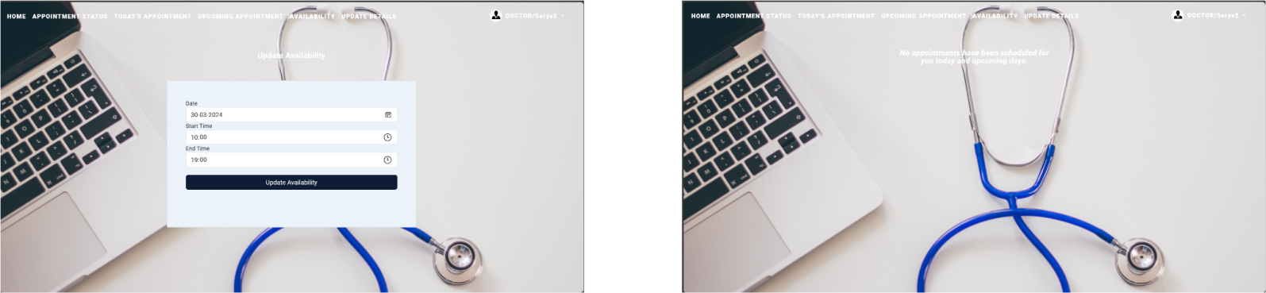

**Patient Module:**

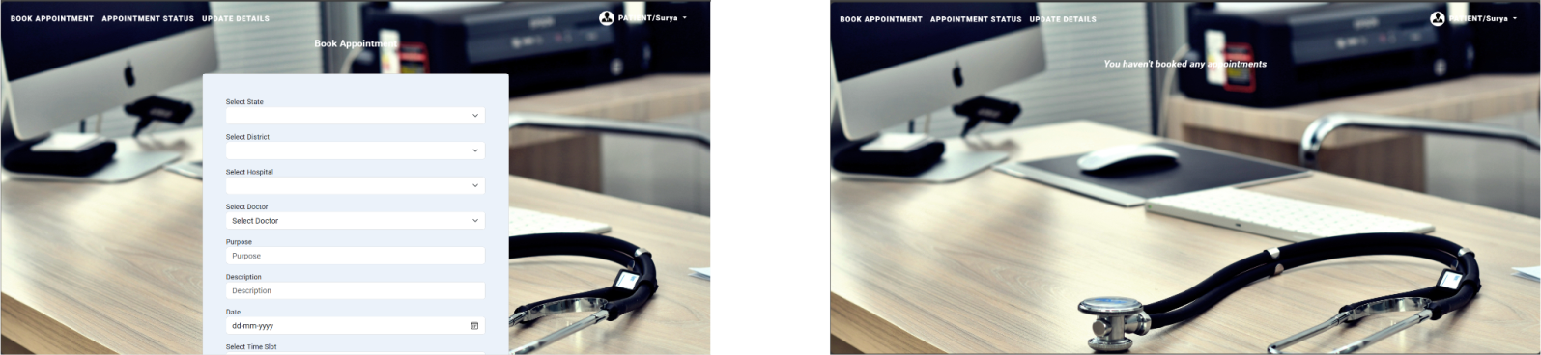

# **XII.CONCLUSION**

Offering a full system for faster appointment scheduling and patient interaction, the Centralized and Integrated Doctor Appointment scheduling Platform (CIDABP) marks a significant development in healthcare management. CIDABP improves the effectiveness, accessibility, and patient and provider satisfaction of the appointment booking process by utilizing cutting-edge design and technology.  
Patients will have a smooth and convenient experience with CIDABP thanks to its user-friendly interface, individualized appointment scheduling, and real-time communication capabilities, which also cut down on wait times and scheduling conflicts.

Furthermore, the comprehensive administrative capabilities on the platform enable healthcare practitioners to efficiently manage appointments, maximize resource utilization, and provide high-quality patient care. Healthcare facilities of all sizes can benefit from CIDABP's versatility and adaptability because to its scalability, interoperability, and future enhancement possibilities. CIDABP is prepared to include new features and technology as the healthcare industry develops, therefore boosting the appointment booking process and boosting patient results.

1. **Acknowledgment**

We would like to express our profound appreciation to everyone who has helped to create and make the Centralized and Integrated Doctor Appointment Booking Platform (CIDABP) a success. This project would never have happened without their commitment, knowledge, and help.

We would especially want to express our gratitude to Ms M Bhuvana, our project supervisor, for all of his help and support during the development process. Their guidance and experience have been crucial in transforming CIDABP into a strong and efficient healthcare administration tool.

We also thank the administrators, patients, and medical experts who took part in the testing and offered insightful comments. Their feedback has been invaluable in helping to improve CIDABP and guarantee its applicability and efficacy in actual healthcare environments.

# We also want to thank Vijay A, Surya D, Vasanth N, Manimurugan S for their contributions to the team's efforts. Their commitment, technical know-how, and spirit of cooperation have been crucial to the development of CIDABP and to guaranteeing its effective execution.

# **References**

**[1]** "Healthcare Management: Principles and Practices" by Peter F. Drucker

**[2]** "Healthcare Information Management Systems: Cases, Strategies, and Solutions" by Marion J. Ball

**[3]** "Healthcare Operations Management" by Daniel B. McLaughlin and John R. Olson